**Proposal: Improvements and maintenance costs for** [***Guide to Polkadot-JS***](https://anaelleltd.github.io/polkadotjs-guide/)***.***

**3. Maintenance**

# Upgrade existing webpages.

Completed for this period:

1. Old format:

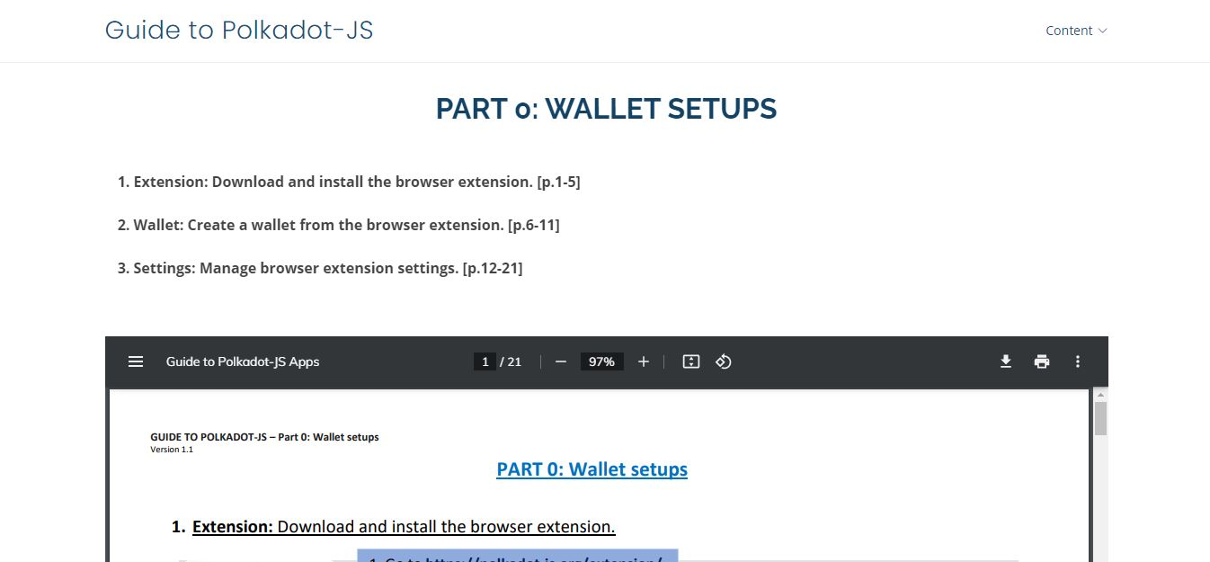

1. New format:

-Web interface

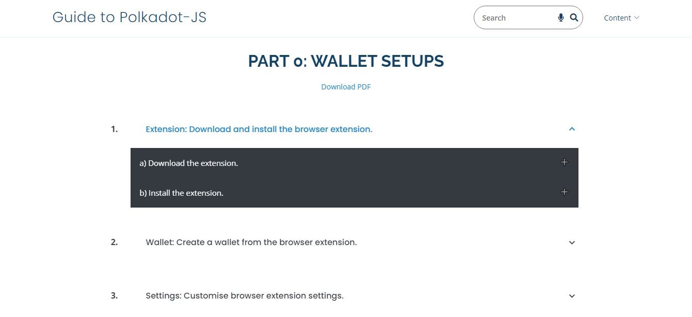

-Search analytics

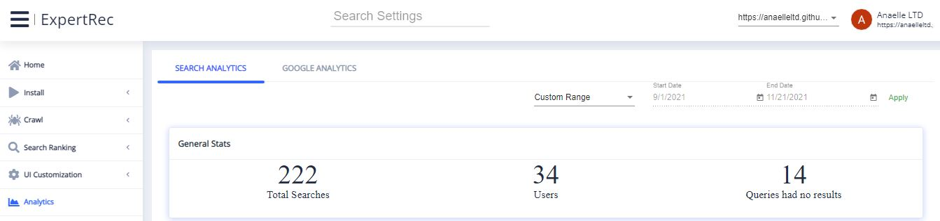

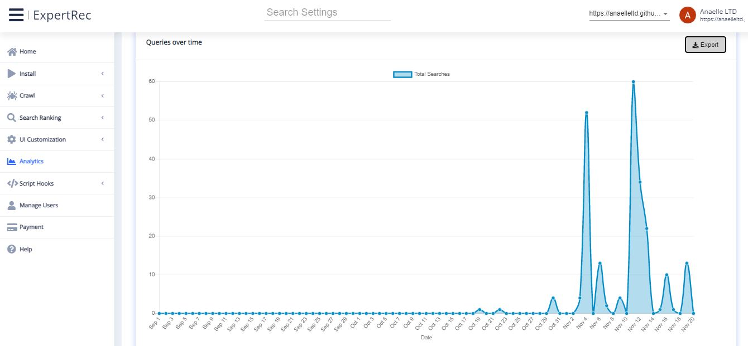

# Deliver all pending sections of ***Part II***.

PENDING

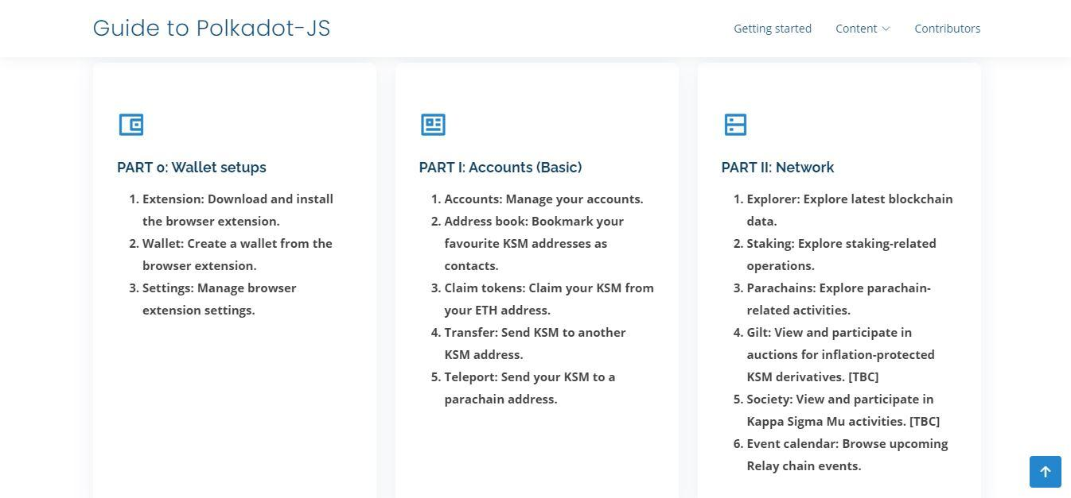

# Include ad hoc explainers on different types of Substrate chains in ***Part V***.

COMPLETED

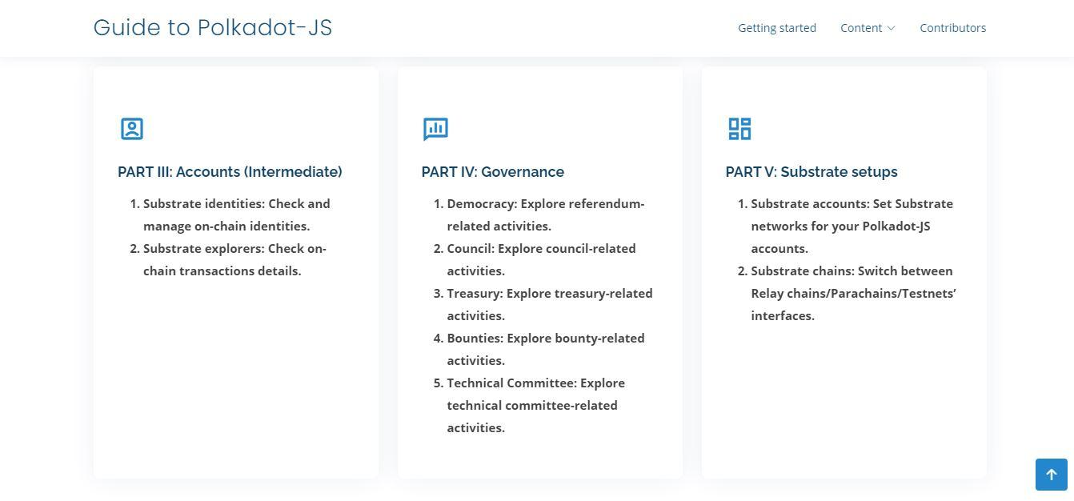

# Deliver all sections of ***Part VIII*** with in-depth explainers.

PENDING

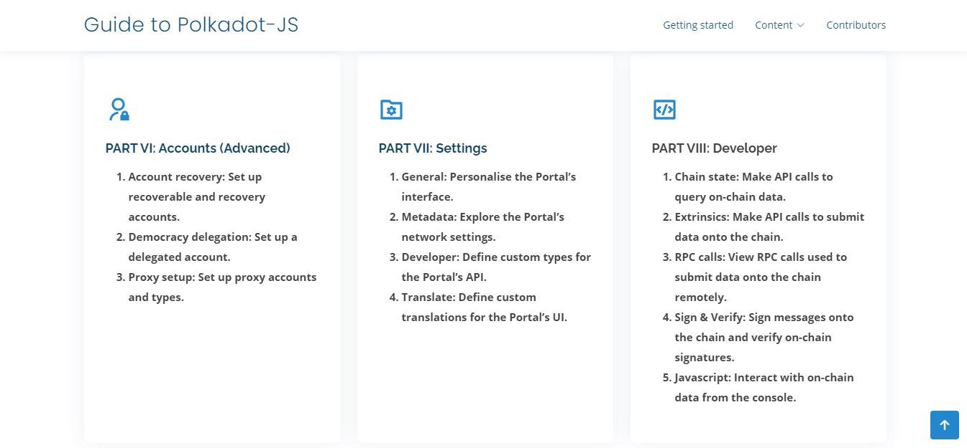

# Reference content on social channels

Completed for this period:

1. Reddit:

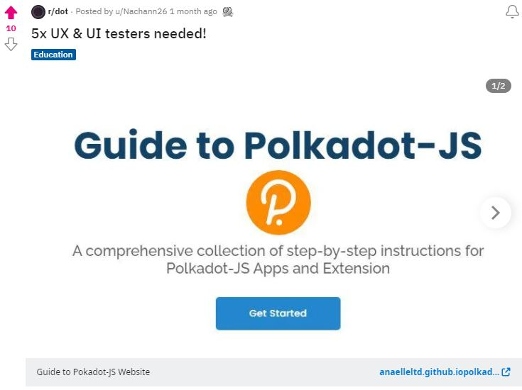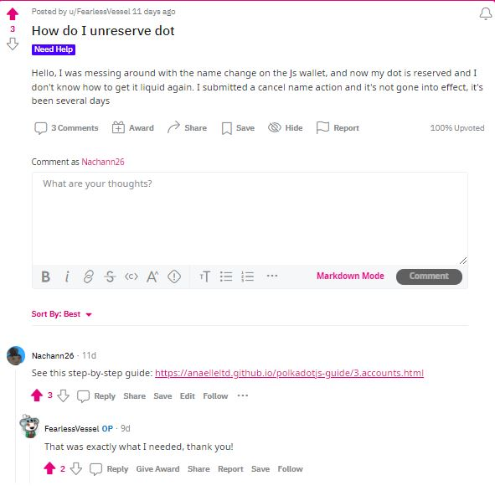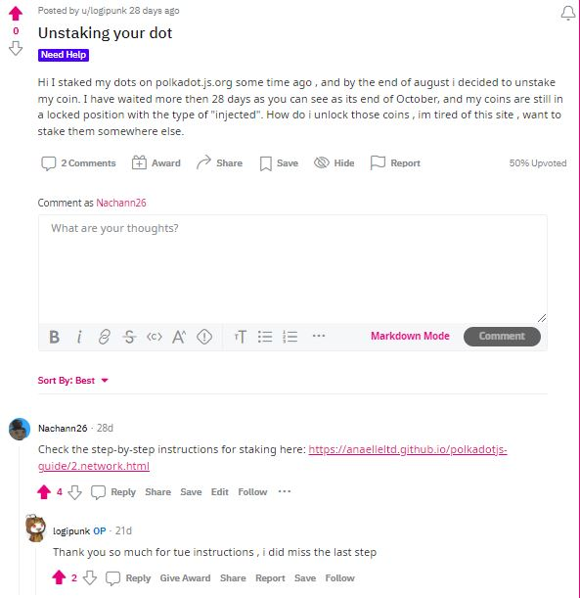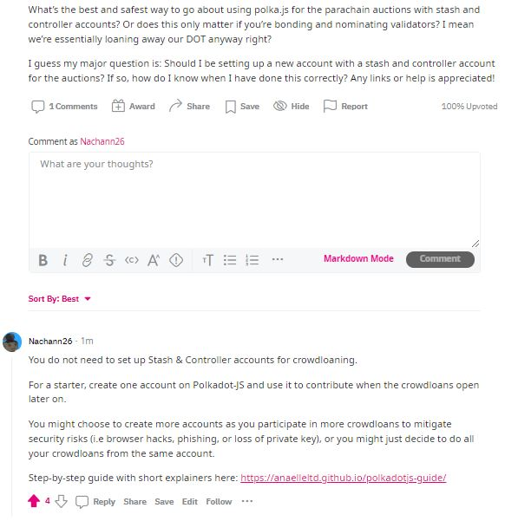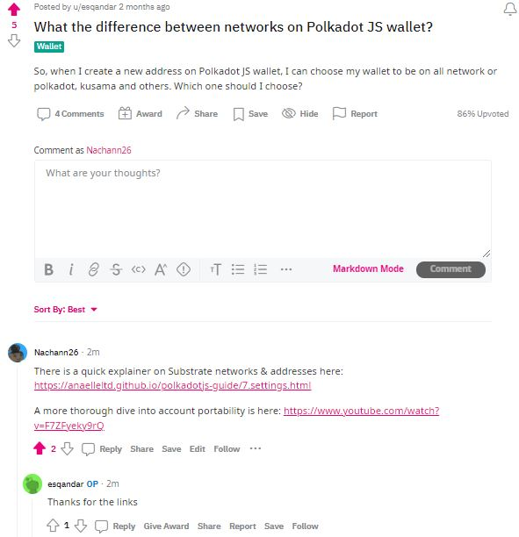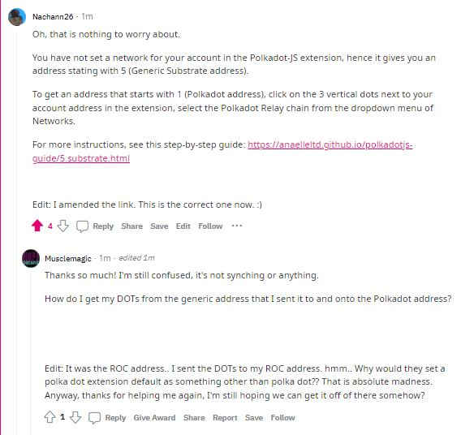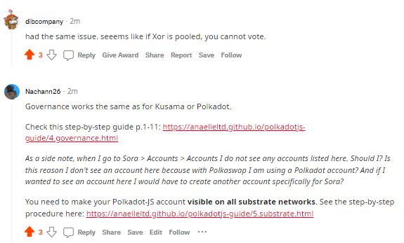

1. Telegram:

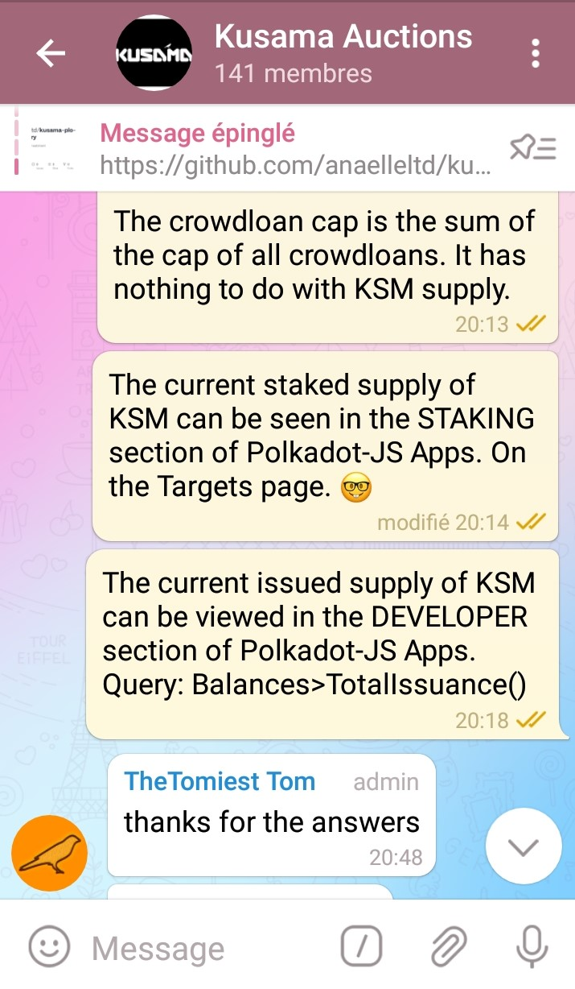 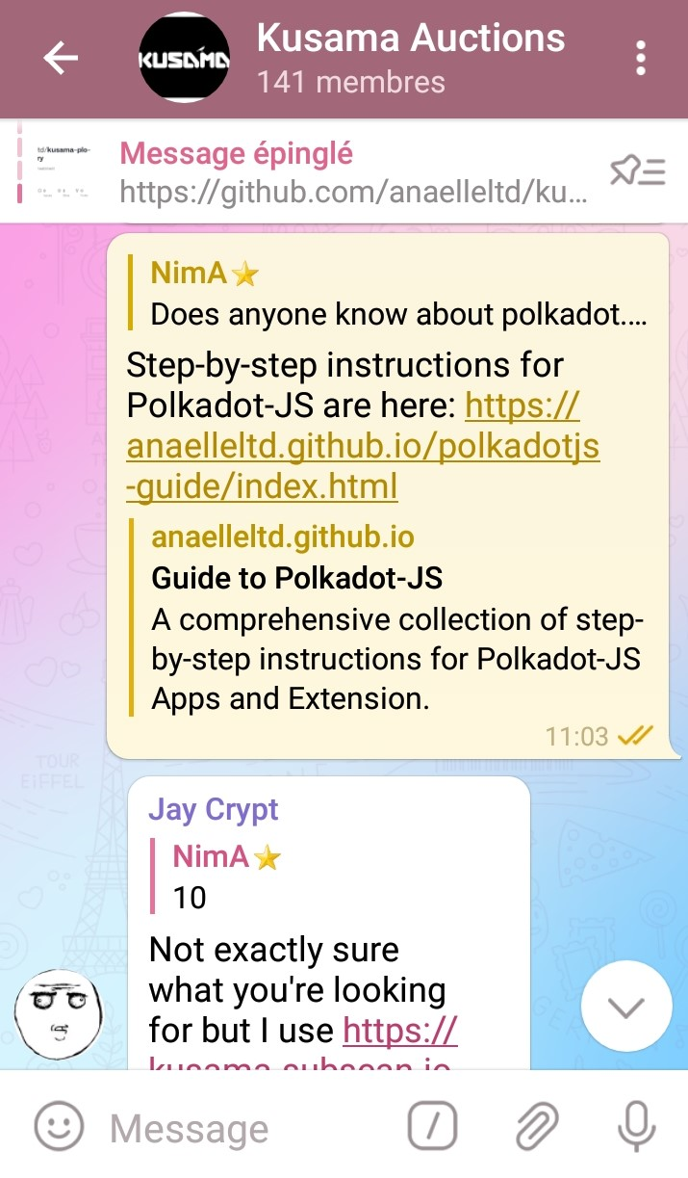

# Monitor traffic on individual pages with Google Analytics

Completed for this period:

1. Number & origin of views:

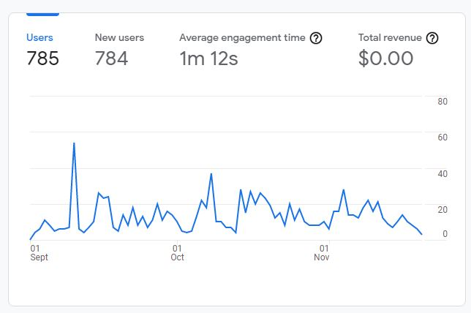

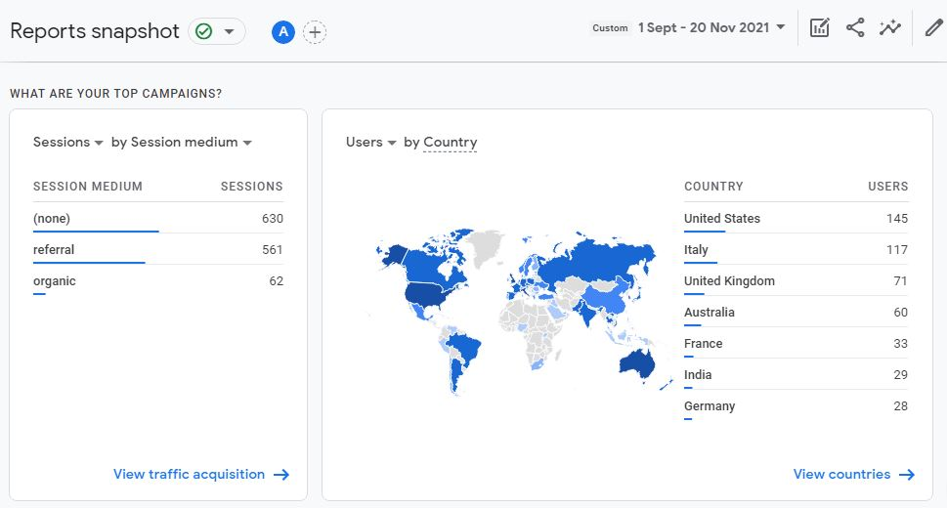

1. Number & origin of new users:

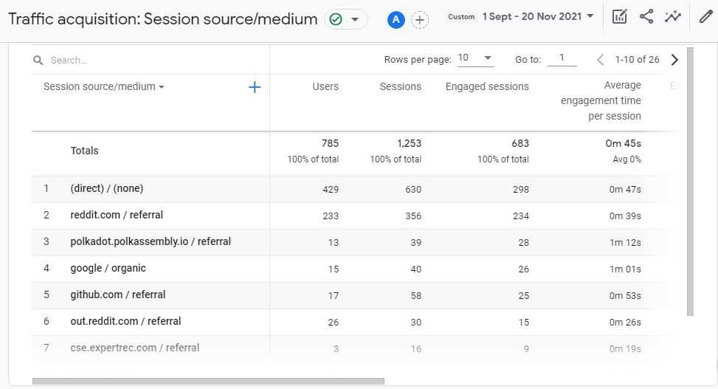

1. Most common user language(s):

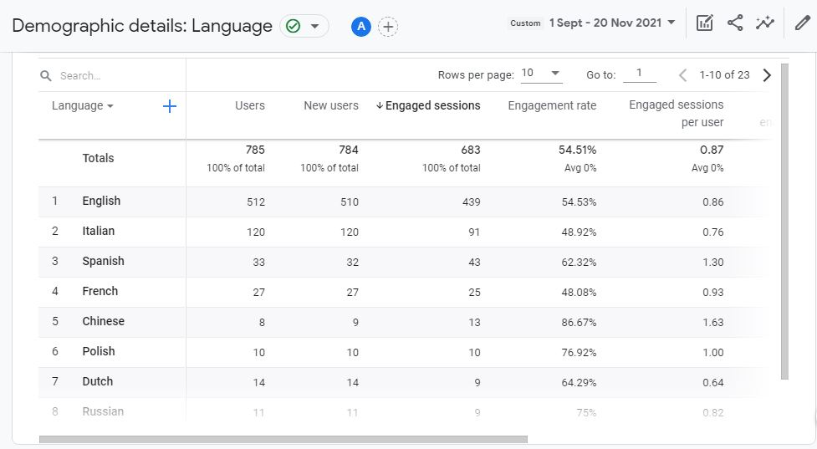

1. Most common user device(s):

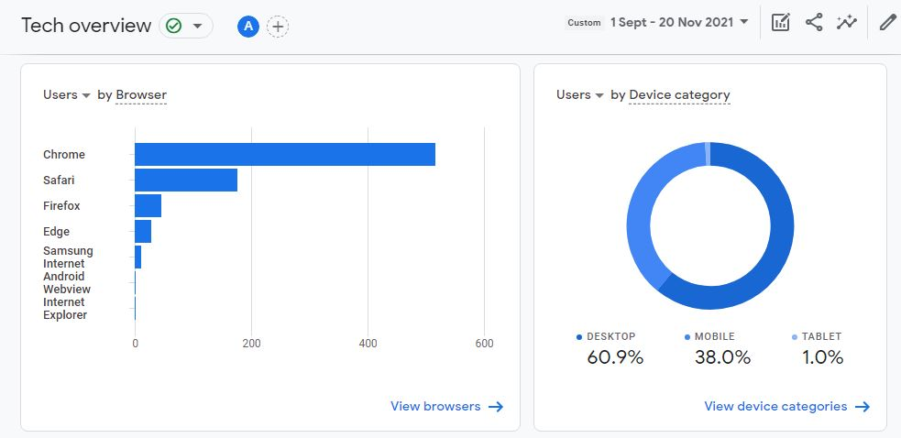

1. Most viewed content(s):

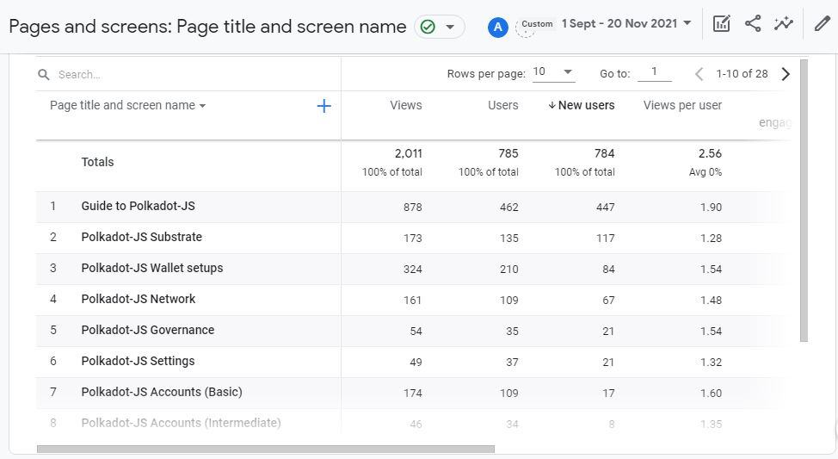

# Deliver new content in line with new/additional Polkadot-JS functionalities.

N/A for this period.